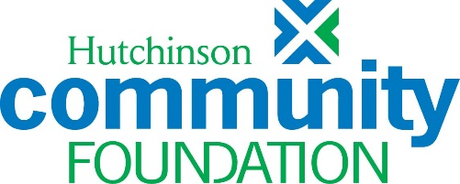

**OUR VISION**

Vibrant and resilient Reno County communities where every person has the opportunity to thrive.

**OUR MISSION**

Inspire philanthropy, leadership and collaboration to strengthen Reno County.

**OUR VALUES**

We are TRUSTWORTHY, building honest and open relationships in stewarding the resources and capital entrusted to us.

We are INNOVATIVE, encouraging experimentation & bold ideas.

We are COMMUNITY-CENTERED, uniting people, organizations, and resources from throughout the community toward a shared vision for our future.

**REQUEST FOR PROPOSALS (RFP) – August 19, 2024**

**Changemakers at Work Grants** - At Hutchinson Community Foundation, we know the critical role that strong personal and environmental connections can play in keeping communities healthy and thriving, and we know Reno County is filled with Changemakers ready to continue sparking those connections.

In the Changemakers at Work Grants program, we put building and nurturing community front and center. We aim to support the work of Changemakers happening in all areas of Reno County, strengthening social capital and community pride. The more social capital a community has and the stronger the sense of place and belonging residents feel, the more committed to each other and the world around them they become. Changemakers at Work grants are made from the Fund for Reno County, our unrestricted community fund for the changing needs of Reno County.

**This program will fund projects that**:

* Bring people together and provide opportunities for positive social interaction and benefit through volunteer work or community-building efforts
* Connect people to the environment around them in new ways to increase community pride and identity
* Build on our communities’ assets and unique qualities through placemaking

**Grants range from $250 to a maximum of $5,000**. The Changemakers at Work Grants Committee may choose to partially fund an applicant’s requested budget. We will not consider multi-year grants nor multiple grant requests from an organization, unless that organization is serving as a fiscal sponsor for multiple groups.

**CRITERIA FOR FUNDING PROPOSALS**

***Who can apply?***

Proposals must come from organizations that are exempt from federal income tax under Section 501(c)(3) and serve Reno County. Proposals from individuals or non-qualifying organizations will not be considered unless they have secured a local nonprofit organization to serve as fiscal sponsor. Applicants and/or fiscal sponsors must conduct business without discrimination on the basis of race, religion, gender, sexual orientation, age, marital status, disability, or national origin.

**PROCEDURE FOR SUBMITTING APPLICATIONS**

Follow the link on the Available Grants page of our website to submit your application through our online platform – Grant Lifecycle Management (GLM).

**Proposals are due by 11:59 PM on Friday, September 27, 2024.**

**TIMELINE**

Applications due by 11:59 PM on September 27, 2024

Awards announced November 12, 2024

Grant period November 12, 2024 – November 12, 2025

Grant report due November 30, 2025

***Contact Sarah Blake at*** [***Sarah@HutchCF.org***](mailto:Sarah@HutchCF.org) ***or 663.5293 with questions.***