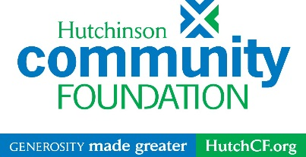

For internal use only

Date received: ____________________

ID Code: __________________________

Grant number: ____________________

CHARLES E. CAREY MEMORIAL FUND
2023 GRANT APPLICATION

Organizational Information
Applicant organization name:
Federal EIN: Year founded:
Organization’s total operating budget:
Mission statement of organization:

Executive Director/Authorizing Official:
Address: City, State, Zip:
Phone: Email:

Grant contact name: Title:
Phone: Email:

Proposed Project Information
Projected number of Reno County residents to benefit from project:
Proposal will fund:
☐ Operating Support ☐ Capacity Building ☐ Equipment ☐ Specific Program
Choose the one project theme that best describes this project or request:
☐ Arts & Culture ☐ Education ☐ Early Childhood
☐ Health ☐ Substance Abuse Prevention ☐ Mental Health
☐ Disability Supports

Funding Request
Amount requested from the Charles E. Carey Memorial Fund:

Project Budget & Project Narrative
Please clearly address the following points. Please limit your total narrative to two pages or less.

List all expenses for the proposed project.
Project Expenses | Amount  (round to nearest whole dollar)
Total Grant Request

Describe how these grant funds would be used, including the activities involved.

Describe the specific needs this funding will address and any change you hope to see as a result of your funded program or project.

How will you know if your program or project is successful?

Full Name | Role on Board | Years of Board Service | Occupation/Work | Phone
Board of Directors
List your Board of Directors, their affiliations, terms, and phone numbers.

SIGNATURES (REQUIRED FOR CONSIDERATION):

__________________________________________ _______________________________________________ __________
(Print) Executive Director/Authorizing Official (Signature) Executive Director/Authorizing Official Date

___________________________________________ _______________________________________________ __________
(Print) Board Chairperson (Signature) Board Chairperson Date

With this signature, the Board of Directors of the Applicant Organization has approved the submission of this grant proposal.

Submit eight printed copies of this application along with the organization’s budget by NOON Friday, January 13, 2023.
Copies must be three-hole punched and paper-clipped. Please do not use staples.

Hutchinson Community Foundation
Attn: Sarah Blake
1 North Main Street, Suite 501
PO Box 298
Hutchinson, KS 67504-0298

